**Chapter 1: Relational Database Concepts**

**Laboratory Activity 1:**

**Laboratory Title: Installing MySQL and Setting Up the Database  
Chapter No. and Topic: Chapter 1 - Relational Database Concepts  
Discussions:  
This activity will guide students through installing MySQL on their system and setting up a basic library management system database.**

**Activity Description:  
Install MySQL, create a new database, and establish connections using MySQL Workbench or command line.**

**Results**: (print screen the result and provide the github link of your work)

Github link: https://github.com/Caye17

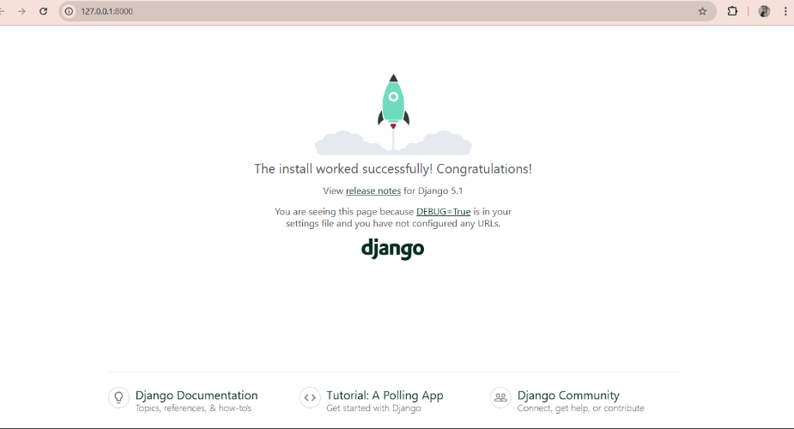

**Follow-Up Questions**:

1. What is the role of a virtual environment in Django development?

A virtual environment in Django development isolates the project’s dependencies from system-wide packages. This ensures that different projects can have their own dependencies without conflicts, allowing for better package management, easier collaboration, and consistency across different development setups.

1. What are the advantages of using Django for web development over other frameworks?

Rapid Development – Django provides built-in tools for common web development tasks, reducing the need for writing repetitive code.

Security – Django follows security best practices by default, protecting against common vulnerabilities like SQL injection and cross-site scripting (XSS).

Scalability – Django’s architecture allows for scaling from small projects to large enterprise applications.

Built-in Features – It includes an ORM (Object-Relational Mapper), authentication system, and admin interface, reducing development effort.

Large Community Support – Being a popular framework, Django has extensive documentation and community support.

**Findings**:

Successfully installing and setting up Django requires a working Python environment and package manager (pip).

A virtual environment is essential to managing dependencies and avoiding conflicts with global packages.

Django’s installation and verification steps are straightforward, and the development server confirms a correct setup.

Renaming the default project directory improves project structure and organization.

**Summary**:

This activity guided us through setting up a Django development environment for building a Library Management System. The steps included installing Python and Django, creating a virtual environment, and verifying the installation. Additionally, we created a Django project and ran the development server to ensure everything was working correctly. This foundational setup is crucial for developing scalable and maintainable Django applications.

**Conclusion**:

Setting up a proper development environment is a crucial first step in Django web development. Using virtual environments ensures better dependency management, and Django’s built-in tools streamline web application development. With Django successfully installed and running, developers can now focus on building the Library Management System efficiently.